Appeal for School Uniform

Shree Amar Jyoti Janata Secondary School is located in Luitel, Gorkha, Nepal. This school has classes from ECD to grade 12 with a total school children 1550 including girls. The children of the pre and primary school age group do not have access to education in the rural remote areas in most of the hilly regions of Nepal. All the children are picked up from far remote communities to the school. These communities have no other schools to send their children. Thus the rural poor people asked the school management to puck up their children and drop back to the communities on free of costs. Most of the cluster communities of this school are ten to thirty minutes one way. Otherwise it takes 45 minutes to 1 hour one way walking which has been preventing the small children in schooling and others also difficult for long walking. The geographical problem is not the only factors that are prevalent in the rural communities. Most of the people are below the subsistence level agriculture, mostly depend on wages if anything comes.; otherwise members of the family migrate to the urban cities for sessional or long-term for work. The mothers and the elderly people are the ones living in the rural communities along with the children. Thus affording the uniforms of the school has also become an additional financial burden in the households in rural communities in Nepal. It has also become another problem for educating the children in the rural cluster communities of this school. Being a local government school, it does not have special funds to support these children. Thus the school must rely on the support of the individuals and organizations. The unit cost per child for the school uniforms is Nrs. 1000 per annum which include 2 pairs of school uniform including socks and shoes and sport clothes. There are 325 girls in this school. We want to provide uniform only to the girls as an incentive for the parents to send their daughters to school and promote girls education, and develop them to be good future leaders. This will be a motivating factor for all the girls who will be in the school education to remain longer period and it will help reduce child marriage in the communities as well if we provide uniform annually. We want to implement this project from January 2020 and continue for a period of five years so that the community will be fully aware the importance girls education in their life. The unit cost of the uniform per child is Nrs. 1000 (i.e. 8 euro/girl). Therefore for the 325 girl students to provide school Uniform, the total cost will be Nrs. 325,000.00 (i.e. 2600,00 euro/year) per year.
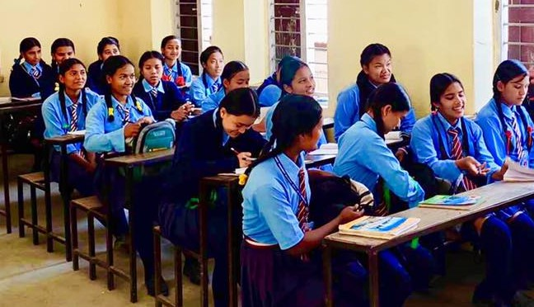
On the occasion of Christmas and New Year 2020, we kindly request you to provide your contributions to help these poor children who will have opportunity to retain in the school throughout the year, and develop themselves healthy and learn to gain knowledge and skills necessary for their future life. Your 100% support goes to the proposed beneficiaries. Our local partner – IDEA, on volunteer basis will monitor the quality of warm meal in the school and report to the concerned authorities. You may wish to donate directly: NL 53 INGB 0006 9092 49
Stitching Global Academy, Amsterdam, NL
For more your inquiries, you may wish to write us at: stichrtingglobalacademy@gmail.com
# stichting Global Academy
Williem de Zwigerlaan 350/2C
1055RD, Amsterdam
The Netherlands

